VHF Super-Regenerative Receiver
I have started straight with the circuit out of the ARRL handbook, by Charles Kitchen N1TEV. I didn't have a 6v8 zener, or a few other part values, so I had to substitute a bit.
Unlike Charles' original circuit I found an audio pre-amp was needed to get sufficient AF gain so the 386 could actually be driven into saturation at full volume. I did have the 386 in its lowest gain configuration (nothing between pins 1 and 8), but the audio was still too weak when I tried it with a gain of 200. The single transistor pre-amp is collector-base feedback biased, which gives high gain, moderate noise, great stability and a good-enough frequency response, it isn't the best topology but it has a low parts count. I used 100n coupling caps in the audio path because I have a huge quantity of them, not because they are a good value choice. That said, the bass response is still quite acceptable, and the monolithic devices are much cheaper/smaller than electros.
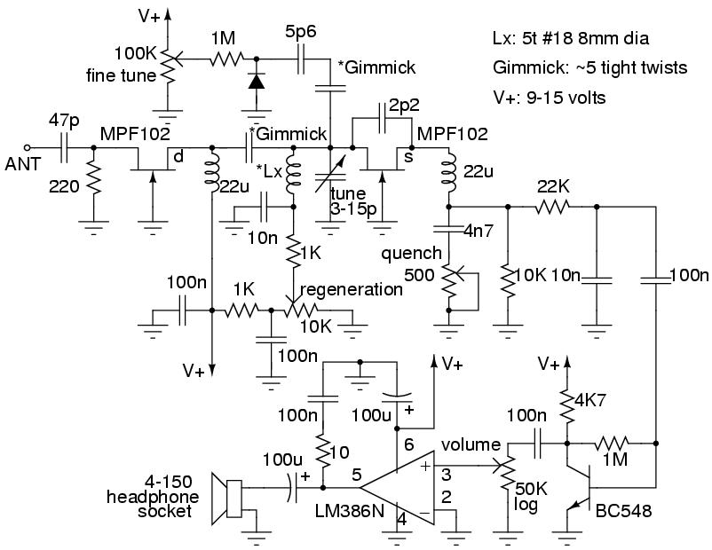

Construction was an organic affair, the unit was built as a prototype, I never intended to finish it off and use it as much as I now do. I listen to FM broadcast radio stations with it almost every night, I even take it to work and listen to the radio there some days.
Note the main tuning coil, it is made from the thick 1.5mm Cu core of house mains wiring. Such wire is cheap, about $1/metre, but contains 2 quite solid conductors, and one stranded (earth) conductor which can be unraveled to give 8 thinner solid wires, or used as-is. The coil must be kept high off the board to reduce stray capacitance for good performance. In hindsite, my choice to use a slab of unetched circuit board for the prototype limits its performance severely. However, it is mechanically robust and forms a low Z ground plain which helps stabilize the receiver.
The audio power amp has a touch of instability operating into higher Z loads with long leads (ie headphones). At high volume levels it can groan. A 10 ohm resistor in its power supply decoupling circuit should fix this, but I haven't bothered to add one yet, I never operate it at more than 1/4 volume (I'd go deaf).
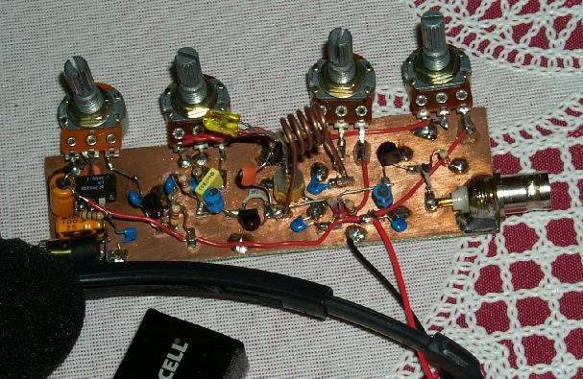
Here is an image of much earlier in the construction, the audio stages were built last (unusual), the audio pre-amp is on the breadboard, tacked to the rest of the circuit by some hookup wire. There is no volume or fine-tune control at this stage, and the interstage coupling is a gimmick (later replaced by a 1p cap).
The coil was attached with IC socket pins, which allowed trying many geometries for performance and to play with different VHF frequency ranges. The thin solid hookup wire used for the main coil was very poor for its performance, the losses being quite high, often the unit would refuse to oscillate at all unless the supply voltage was raised to 15v and the drain-source feedback cap tweaked.
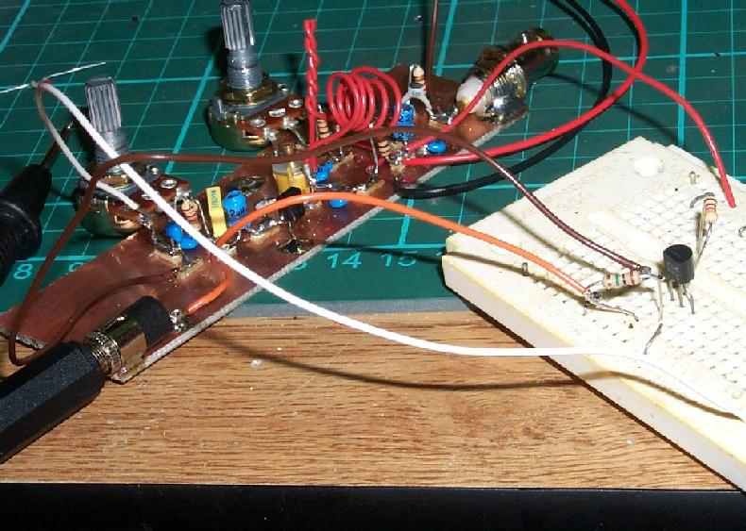
Here is a spectrogram of the receiver in regenerative oscillation. There is no quenching here, it is just making a pure RF sine wave, there is only modest amplification in this mode (there would be more if the regeneration was backed off to the edge of oscillation, but then there would be nothing to see), the selectivity is enormous, you can beat carriers of FM stations, even an AM signal generator's 1.5kHz sidebands are resolved and can be beat separately without a lot of heterodyne from the other 2 line frequencies (carrier and other sideband) in the audio passband, this is straining the stability of the receiver though, the fine tune control is a must to be able to keep up with the thermal drift from your breath.
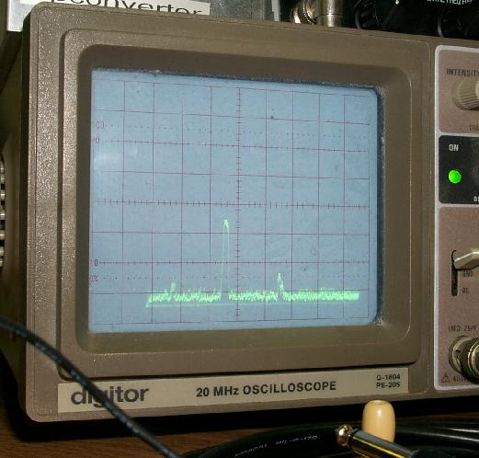
Here is a spectrogram of the receiver in super-regenerative oscillation. The quenching rate is about 120kHz, the waveform looks rather sawtooth like, but has smooth edges. The spectrum analizer's IF bandwidth is about 100kHz, so it doesn't really resolve the quenching sidebands and their harmonics, but you can see the sinc shaped envelope of the higher harmonics due to the scan rate harmonically beating with them.
While the poor IF selectivity of my SA has smudged the details it appears that the main oscillation is actually FMed as well as AMed by the quenching oscillation. It makes sense, the operating point (and hence the drain capacitance) of the FET is being pulled around by the quenching oscillation voltage on the source. This makes it much more complex to say what is really going on during the FM demodulation. The slope can't be too flat, and could be quite complex. I would like to investigate this mathematically in the future.
